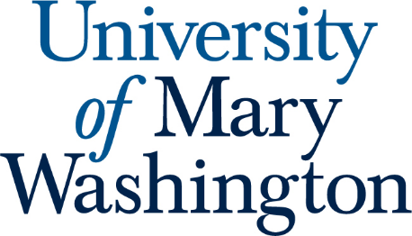

FSEM Committee
August 27, 2024 Regular Meeting
Time and Location: 3-4pm, DuPont324

In attendance:

2024-2025 FSEM Committee
- 2025 Bridgette Dennett, Chair (Assistant, CAS)
- 2025 Marcus Leppanen, Secretary (Assistant Professor, CAS)
- 2025 Virginia Mackintosh (Professor, CAS)
- 2026 Gary Richards (Professor, CAS)
- 2027 Ginny Morriss (Professor, CAS)

EX OFFICIO MEMBERS
- April Wynn, Director of the First-Year Experience

Guest Member (Non-voting role)
- October Edwards, Research and Instruction Librarian

- Introductions
- Old Business:
  - Review of Proposal Calendar
    - Proposals due October 16th (Wednesday after fall break)
    - Initial comments on proposals will continue to be made via online form again
    - Committee will meet November 1st to discuss comments and to make final decisions
      - Deadline for our decisions is November 4th to meet UFC deadline
  - The committee is petitioning the UFC for the ability to have final approval over FSEM proposals. This request should be on the Sept meeting agenda.
    - Committee approves of continuing in this direction
    - What factors need to be figured out and why do we want to do this?
      - Language in the handbook can be used to support our case
        - Other designations (e.g., SI, WI, AMW) have approval processes that differ from FSEM
        - Our role is to determine qualifications for teaching an FSEM
      - Need to determine who we report to as a committee
        - Currently this is UFC
      - We need more flexibility than UFC schedule allows
      - Need to ensure we still follow university guidelines
  - Discuss the next steps for the new Leaning Outcomes
    - Committee discussed these in Spring 2024 and input received from Provost needs to be integrated
    - Provost wants bigger changes to the FSEM program than just updates to SLO’s
      - Consideration was given to where skills are being learned if not in FSEM
    - Committee discussed status of the current FSEM and potential updates
    - Need to pause pushing out new SLO’s from Spring to avoid confusing people during reorganization changes
- New Business:
  - Need to set Proposal Workshops before Fall Break
    - Mid/late September
      - Announcement about workshops going out soon
      - This year will be by registration to help committee organize attendance
      - Zoom option will also be provided
    - M/W/F option
      - Wednesday, October 2nd from 3:00-4:00
    - T/Th option
      - Tuesday, October 1st from 3:30-4:30
    - Bridgette will work on reserving space in Seacobeck 105, or HCC as secondary option
  - There is a review of the committees and the university governance structure this year. To this end, the UFC is asked the committee to consider the following:
    - Option 1: Reduce membership to 3 faculty.
    - Option 2: Maintain 5 faculty and merge with the General Education Committee.
    - As an advisory committee, clarify what unit this committee advises.
    - The current iteration of the Faculty Handbook states that the committee has an ex officio that is appointed by the provost. The Faculty Handbook working group recommends that this language is changed so that the ex officio member is the Director of the First Year Experience.
      - Committee recommended that changes to committee structure that would affect the handbook should be put on hold
      - Of the options provided, the committee supported remaining at five members to maintain diversity of experience and opinion
        - Committee discussed alternative options that may be recommended to UFC in the future
- Upcoming Meetings:
  - Sept 27th @ 3-4pm
  - Nov 1st @ 3-4pm
  - Dec 6th @ 3-4pm
- Meeting adjourned: 4:05

